SAP CAPM Java Project Setup Guide

Step 1: Login to SAP Business Application Studio

1. Open your web browser and navigate to the SAP Business Application Studio URL provided by your administrator or login to SAP BTP Cockpit and navigate to BAS service.
2. Log in using your SAP credentials and sign in with Default Identity Provider.
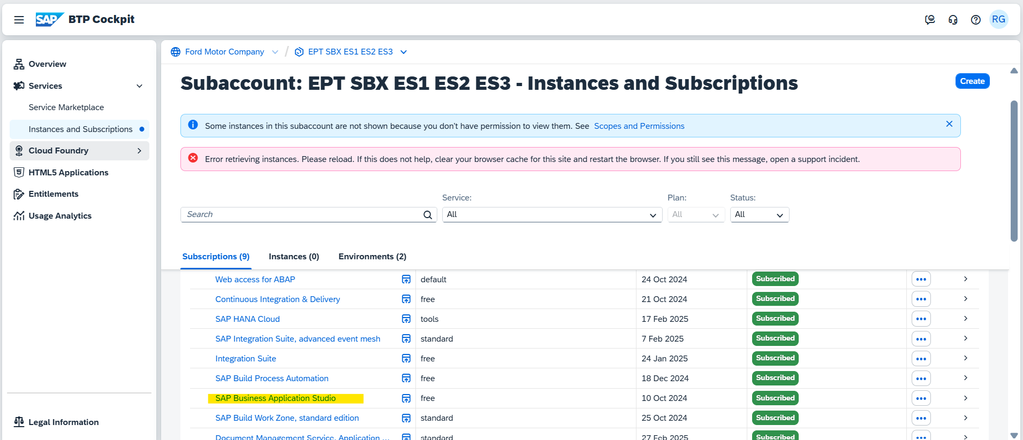
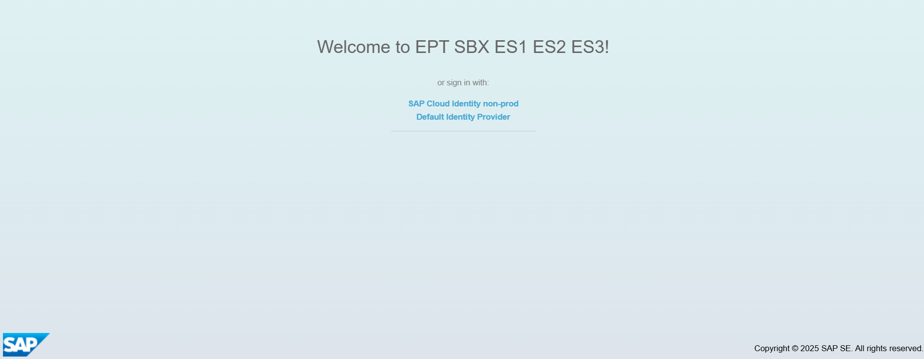

Step 2: Create a Development Space

1. Once logged in, click on the Create Dev Space button.
2. Enter a name for your dev space (e.g., `barvolume-service-dev`).
3. Select the Full Stack Cloud Application dev space type.
4. Click on the Create Dev Space button and wait for the dev space to be created and started.
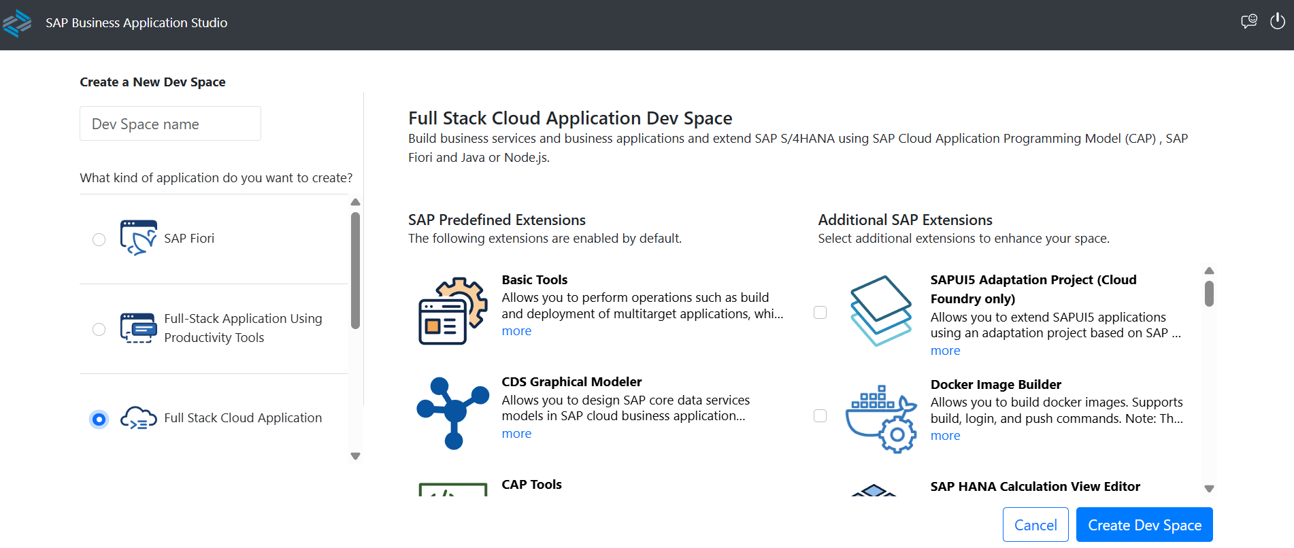

Step 3: Create Application Skeleton

1. Open a terminal in your dev space in projects folder.
2. Initialize a new CAP project with Java support with commad:
- cds init barvolume-service --add java

3. Navigate to the project directory:
- cd barvolume-service

4. Install the project dependencies and build the project:
- mvn clean install

5. Run the project using Spring Boot:
- mvn clean spring-boot:run

The skeleton of database project has been created as below:
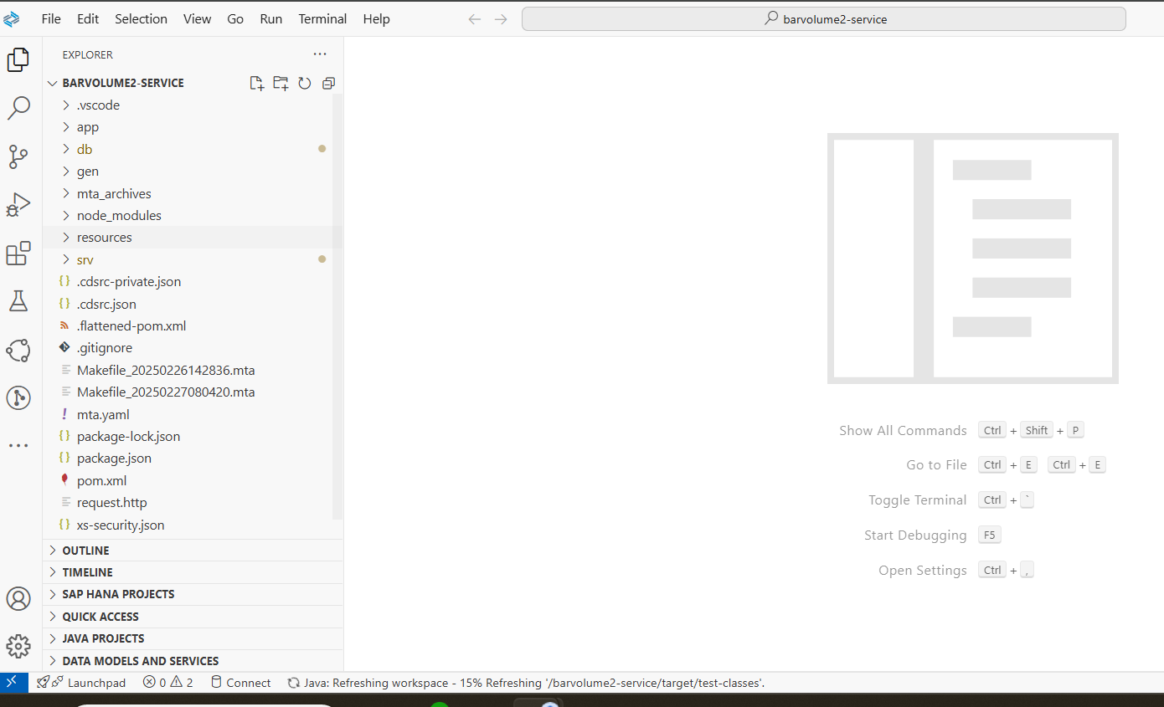

Step 4: Create `schema.cds` in the `db` Folder.

1. In the `db` folder, create a new file named `schema.cds`.
2. Define your database schema in `schema.cds`. For example, to create a `Barvolume` table:
cds
namespace sap.capire.barvolume2;

entity ZTSTP_BAR_VOLUME {
key UUID : UUID;
PartNumber : String(40);
PlantNumber : String(4);
Supplier : String(5);
PurchaseGroup : String(10);
NewPurchaseGroup : String(10);
CostBin : String(4);
Cost : Decimal(11,2);
Currency : String(3);
ThresholdQty : Decimal(10,2);
BUoM : String(3);
BARGroup : String(10);
PricingUnit : Decimal(10,2);
CumulativeGRQuantity : Decimal(10,2);
EffectiveDate : Date;
GRThreshold50 : Boolean;
GRThreshold75 : Boolean;
GRThreshold95 : Boolean;
GRThreshold100 : Boolean;
Title : String(50);
Description : String(600);
Status : String(16);
ClaimNumber : String(10);
Remarks : String(50);
Dummy : Boolean;
Attachment : LargeBinary;
DocumentId:String(50);
CreationDate : Date;
ChangeDate : Date;
CreatedBy : String(8);
ChangedBy : String(8);
}

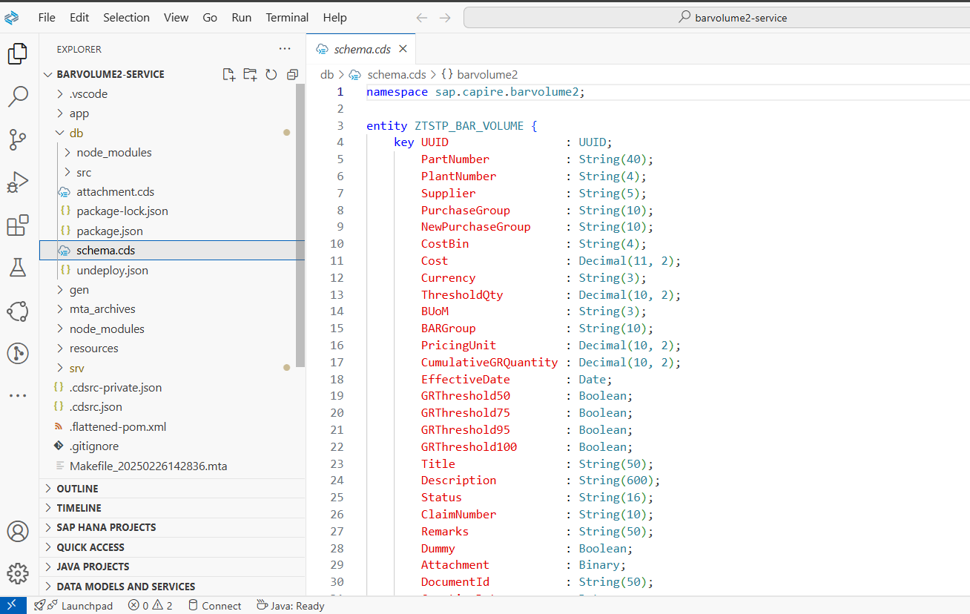

Step 5: Create Entity and Projection in the `srv` Folder.

1. In the `srv` folder, create a new file named `service.cds`.
2. Define your service and its projection on the `Barvolume` table:
cds
using { sap.capire.barvolume2 as my } from '../db/schema';

service barvolumeList @(
path: '/barvolume'
) {
entity barList as projection on my.ZTSTP_BAR_VOLUME;
}
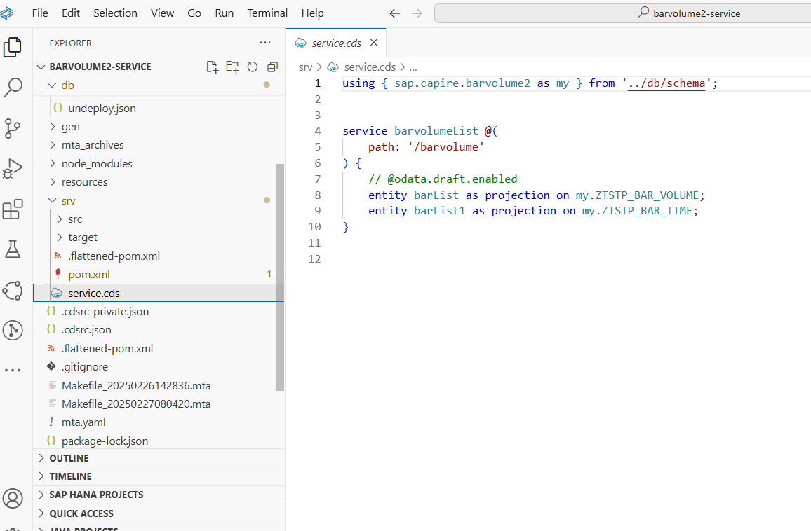

Step 6: Add Required Features for Production

1. Add HANA, MTA, XSUAA, and AppRouter configurations for production and run below command:
- cds add hana,mta,xsuaa,approuter --for production
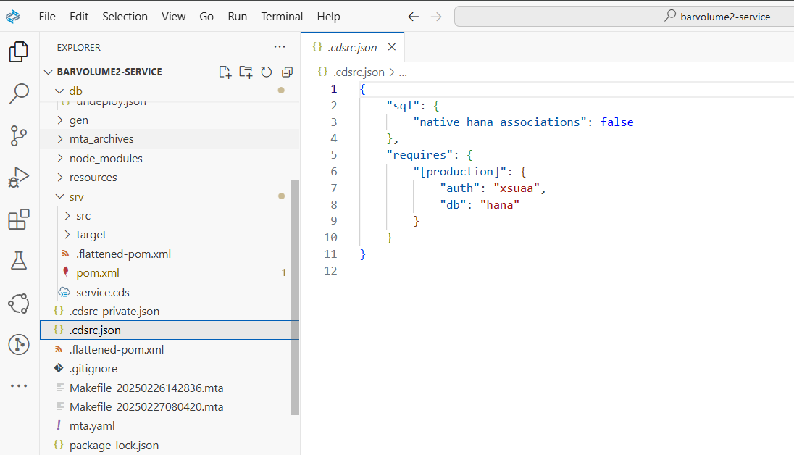

Step 7: Build the MTA Archive

1. Build the MTA (Multi-Target Application) archive:
- mbt build -t gen --mtar mta.mtar
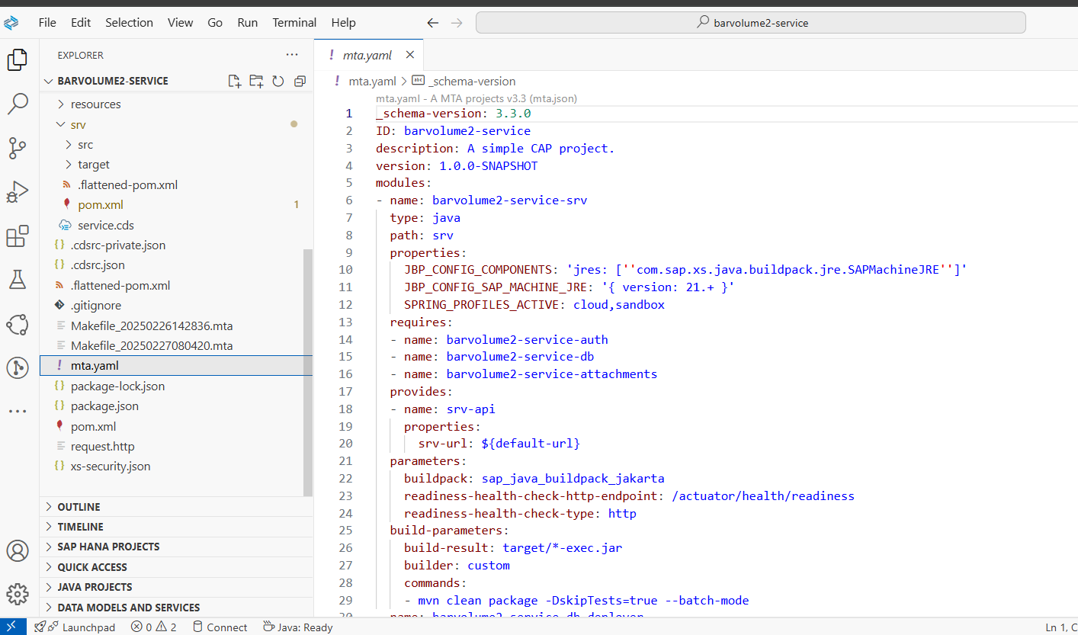

Step 8: Deploy the MTA Archive to Cloud Foundry

1. Deploy the generated MTA archive to Cloud Foundry:
- cf deploy gen/mta.mtar
Once deployed successfully, app will be accessible from cloud foundry.
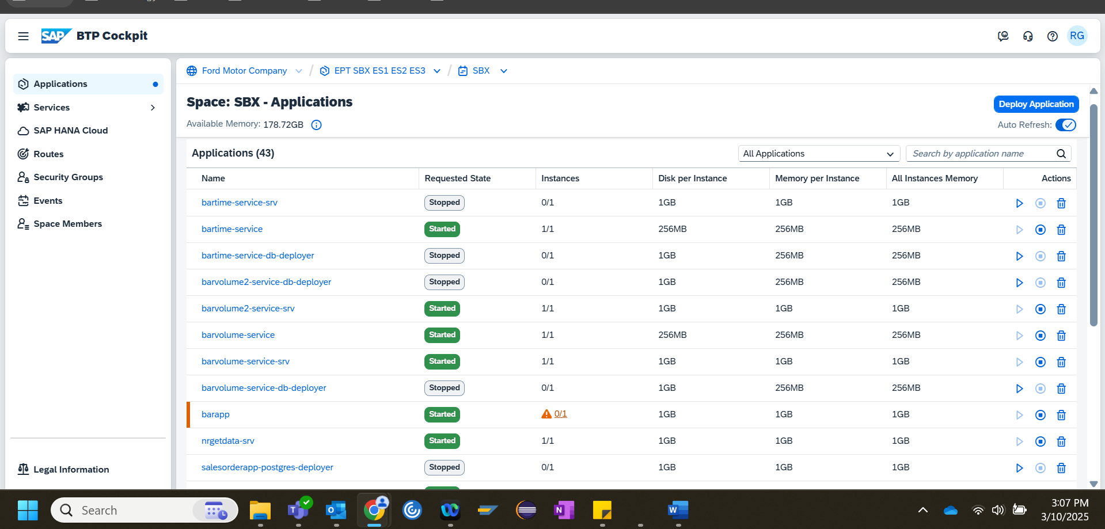

Step 9: Hybrid Testing

1. Bind the database service for hybrid testing:
- cds bind db --to barvolume-db

2. Start the CAP server in hybrid mode:
- cds watch --profile hybrid
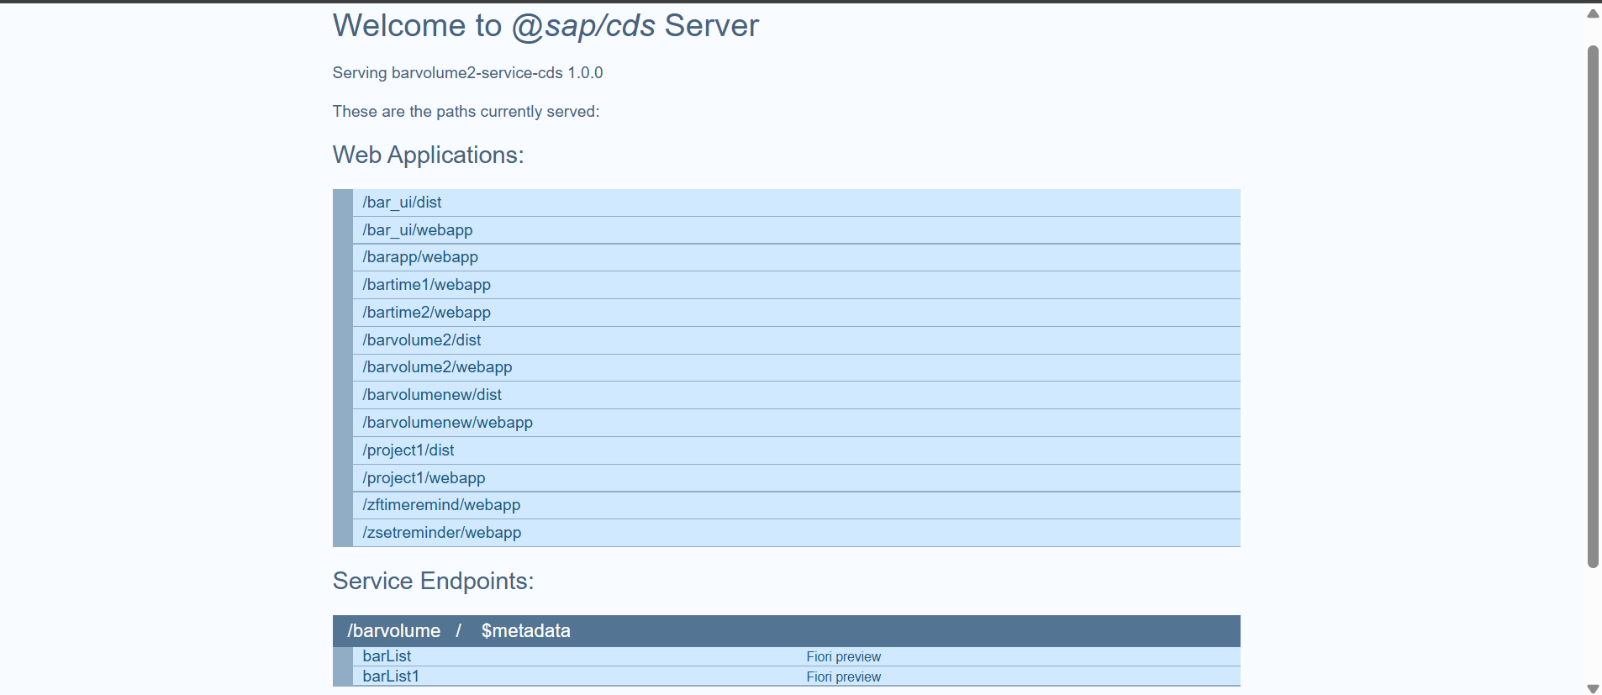

Step10: Add UI

- Integrate the CAP service to UI by creating Fiori application in project by creating MTA module from Template.
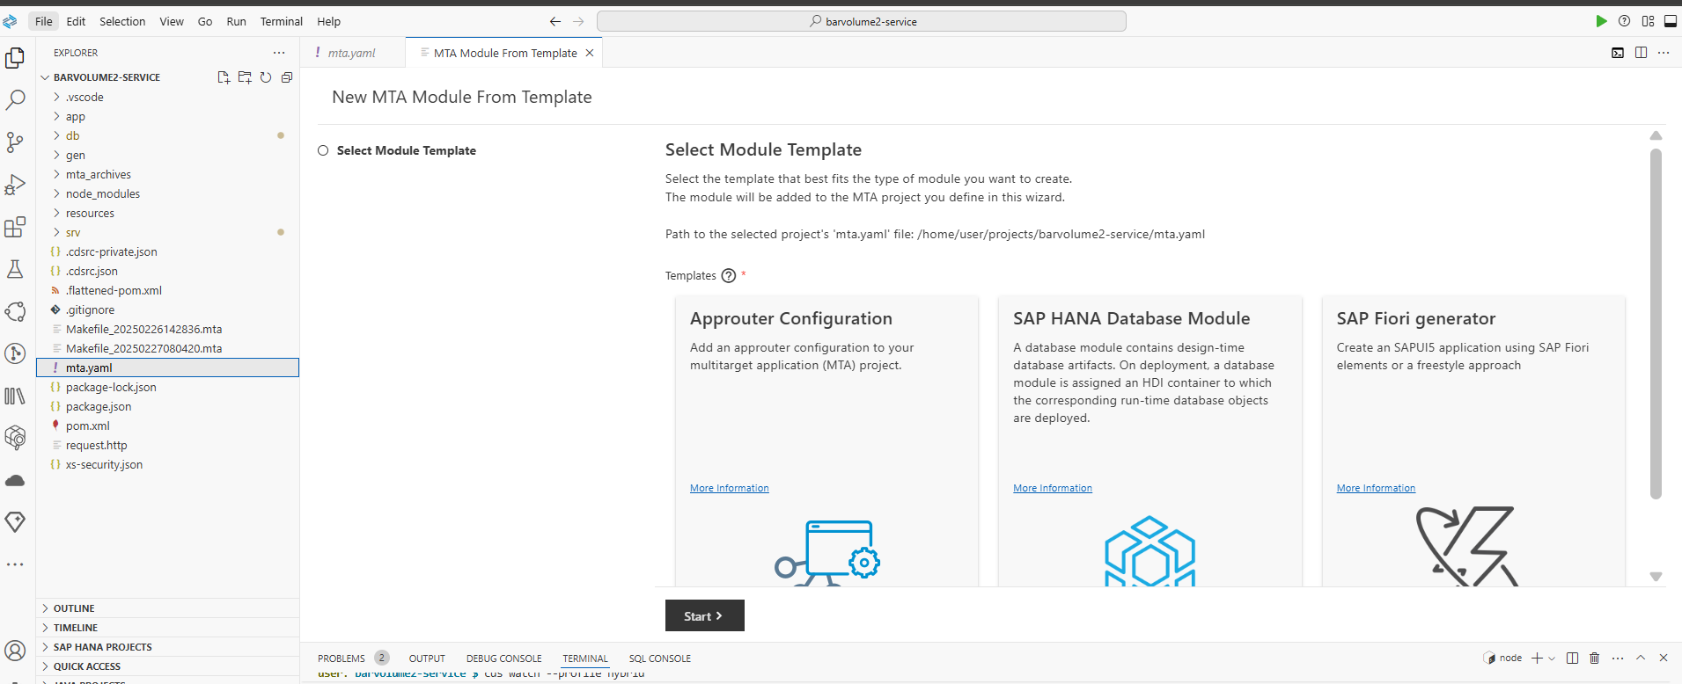
- Select the template that best fits the type of module you want to create.
- Configure the data source and select a service.
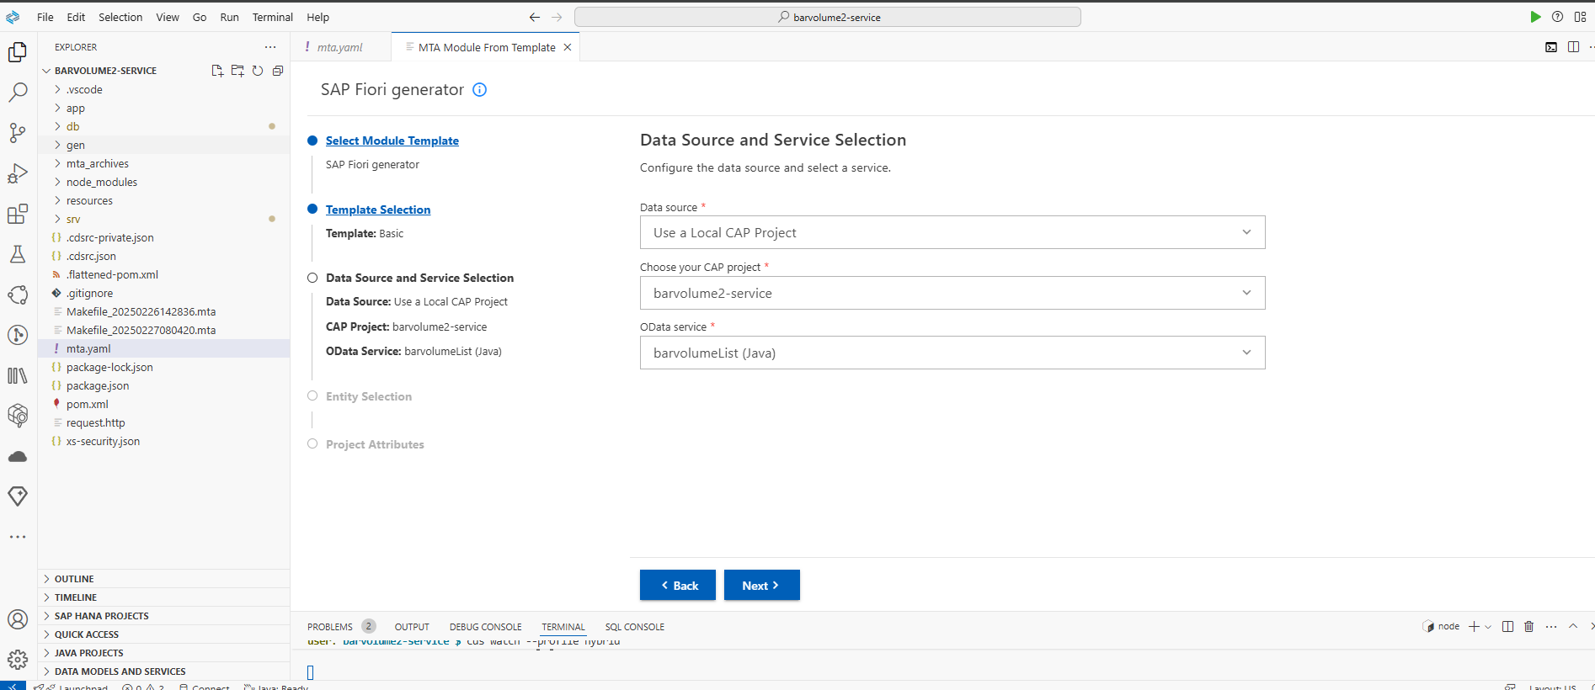
- Configure the selected service with required Entity.
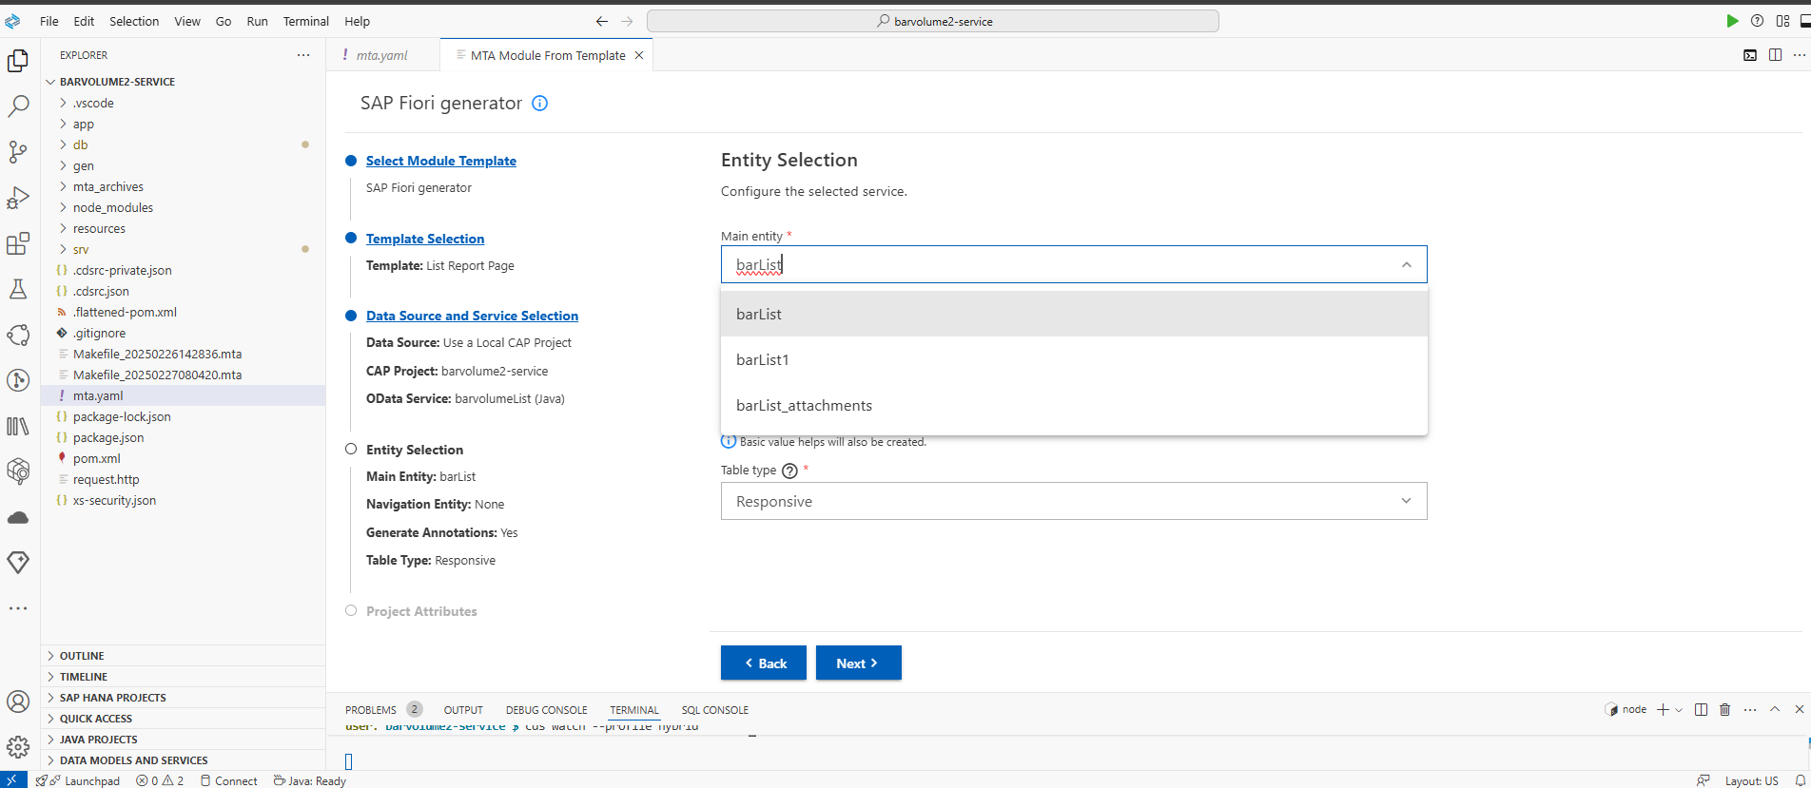
- Configure the main project attributes.
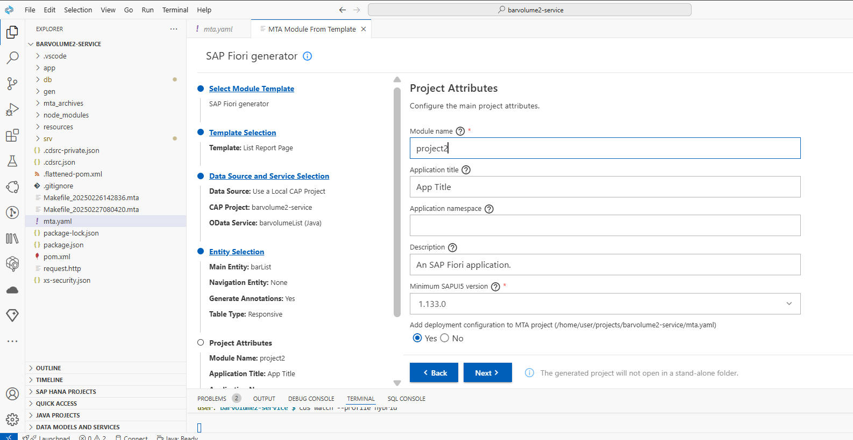

- Configure deployment settings and finish to create the app.
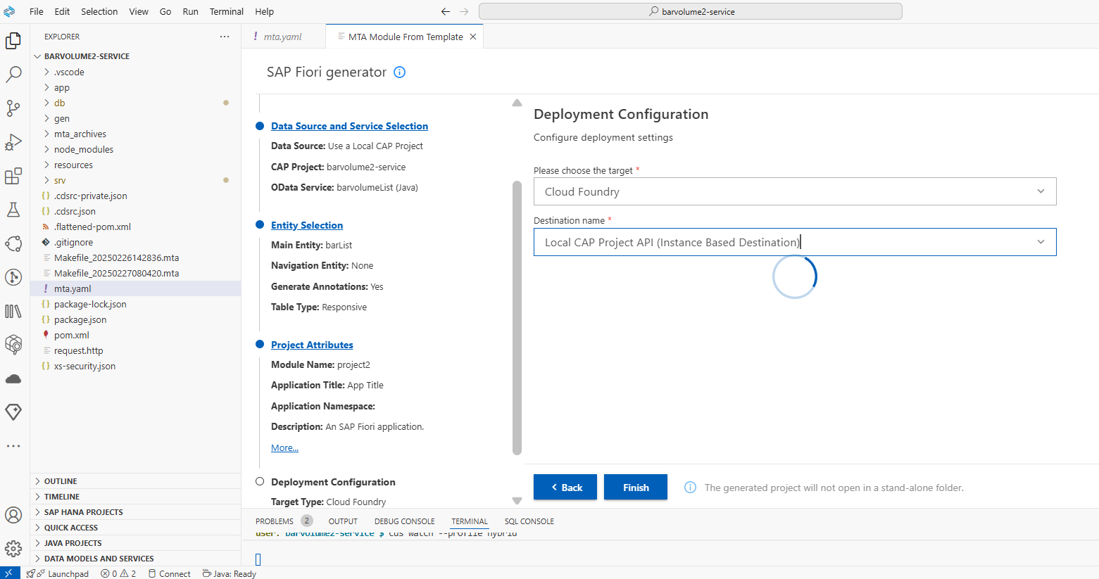

Step 11: Run Application

Follow the Step 9, run 2nd command and select the `/barvolume2/webapp` from list of web apps created to run.

